| To: Parents of pupils attending Ysgol Gynradd Gymraeg Rhyd Y Grug |
| --- |
|  |
|  |
|  |



| Canolfan Ddinesig, Stryd y Castell,  Merthyr Tudful, CF47 8AN |
| --- |
|  |
| Civic Centre, Castle Street,  Merthyr Tydfil, CF47 8AN |
|  |
| Ffôn/Tel: **(01685) 725000**  [**www.merthyr.gov.uk**](http://www.merthyr.gov.uk)  Croesawn alwadau yn y Gymraeg  We welcome calls in Welsh |

|  |  | Dyddiad/Date: | | **28 October 2022** |
| --- | --- | --- | --- | --- |
| **Ein Cyf./Our Ref.:** | **LH/HC** | **Gofynnwch am/Please ask for:** | | **Laura Hopkin** |
| **Eich Cyf./Your Ref.:** |  | **Llinell Uniongyrchol/Direct Line*:*** | | **01685 725141** |
|  | | **e-bost/email:** | **Laura.hopkin@merthyr.gov.uk** | |

Dear Parent

**EDUCATION ACT 1996**

**GOVERNING BODY OF YSGOL GYNRADD GYMRAEG RHYD Y GRUG**

**ELECTION OF ONE PARENT GOVERNOR**

I wish to inform you that we are seeking nominations for 3 parent representative on your school governing body. Parent governors are elected by and from parents and guardians of children at the school. Anyone who is the parent or guardian of a child attending the school is entitled to stand for election and to vote in the election.

Meetings of the governing body have to be held at least once a term. The term of office is four years and a parent may continue as a governor even if his/her child has left the school during that period. There will also be opportunities to participate in a variety of training events.

Should you require any further information on the duties and responsibilities of a Parent Governor, please contact the above number or the headteacher. In the meantime, if you wish to offer yourself as a candidate for election, please complete and return the nomination form attached to your child(ren)’s school no later than **Friday, 11 November 2022**.

It may be helpful if you include a short statement about yourself, which will be included on the ballot forms that will be issued to parents. The statement should be no more than 50 words. Please ensure that you read the notes on the attached form to ensure that you are eligible to serve as a governor.

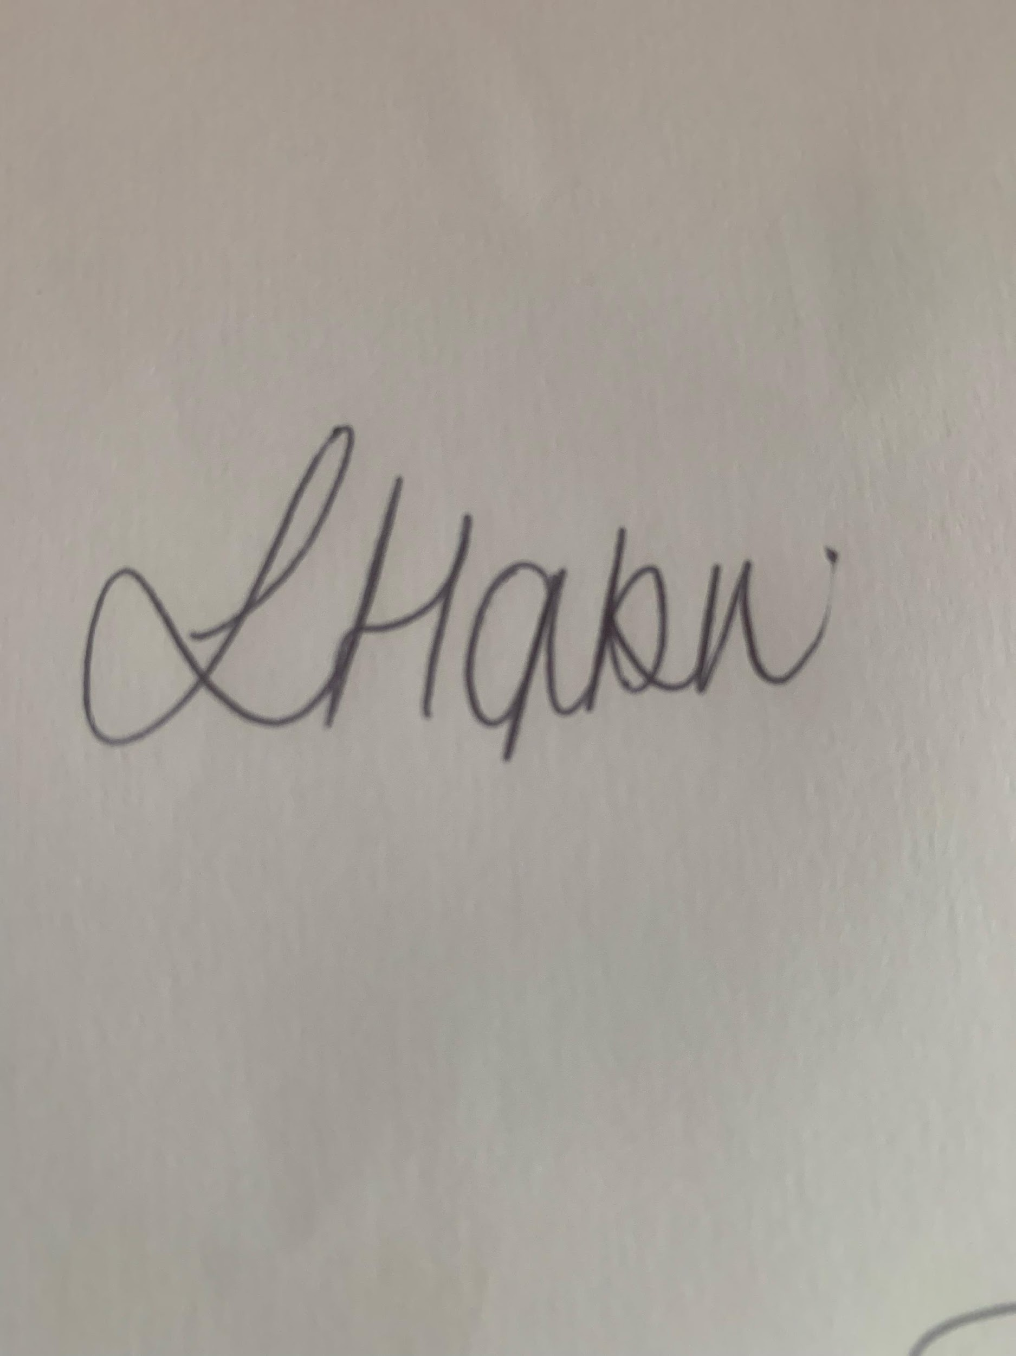

Yours sincerely

**Laura Hopkin**

**Clerk to the Governors**

**NOMINATION FORM - ELECTION OF PARENT GOVERNOR TO THE**

**GOVERNING BODY OF YSGOL GYNRADD GYMRAEG RHYD Y GRUG**

**(BLOCK LETTERS PLEASE)**

**NAME:**

**ADDRESS:**

**CHILD’S NAME**

**E-MAIL:**

**TELEPHONE:**

**You may, if you so wish, include a brief statement about yourself in the box below**

**(NO MORE THAN 50 WORDS)**

**NOTE:**

DISQUALIFICATION FROM SERVICE AS A GOVERNOR

Appointment as a governor is subject to certain regulations which disqualify persons from becoming governors. Governors should:-

1. be aged 18 or over at the time of his/her election or appointment. Pupils may be governors but few are likely to be eligible;
2. not hold more than one governorship at the same school;
3. not be a governor at more than two schools (unless as an ex-officio or temporary governors or an additional governor at a school causing concern).
4. Parent governors must be the parent or legal guardian of a child currently attending the school.
5. not be an ex-officio governor specified in the instrument of government of more than two schools:
6. not be bankrupt or disqualified under the Company Directors Disqualification Act 1986 or an order made under section 429(2)(b) of the Insolvency Act 1986;
7. not have been removed from the office of charity trustee or trustee for a charity by the Charity Commissioners or High Court on grounds of any misconduct or mismanagement, or under section 7 of the Law Reform (Miscellaneous Provisions) (Scotland) Act 1990 from being concerned in the management or control of any body;
8. not be included in the list of teachers or workers prohibited or restricted from working with children or young people (currently classed List 99);
9. not be disqualified from being a teacher, other school employee or an independent school proprietor;
10. not have been sentenced to 3 months or more in prison (without the option of a fine) in the 5 years before becoming a governor or since becoming a governor;
11. not have received a prison sentence of 2 ½ years or more in the 20 years before becoming a governor;
12. not at any time have received a prison sentence of 5 years or more;
13. not have been fined for causing a nuisance or disturbance on school premises during the 5 years prior to or since appointment or election as a governor; and
14. not also act as clerk.

OTHER IMPORTANT INFORMATION

* All new governors will have to complete mandatory induction training (a course of approximately 2 hours) within one year of their appointment.
* Governors will need to abide by any code of conduct which has been adopted by the governing body (a copy is available at the school)
* You may be required to provide additional information to enable an appropriate check to be made by the Disclosure and Barring Service.

I confirm that I am prepared to stand for election as a parent governor to the governing body of the above-mentioned school. I have read the notes set out above and declare that I am not disqualified from serving as a school governor.

**SIGNED**:…………………………………………… **DATE**:…………………………………